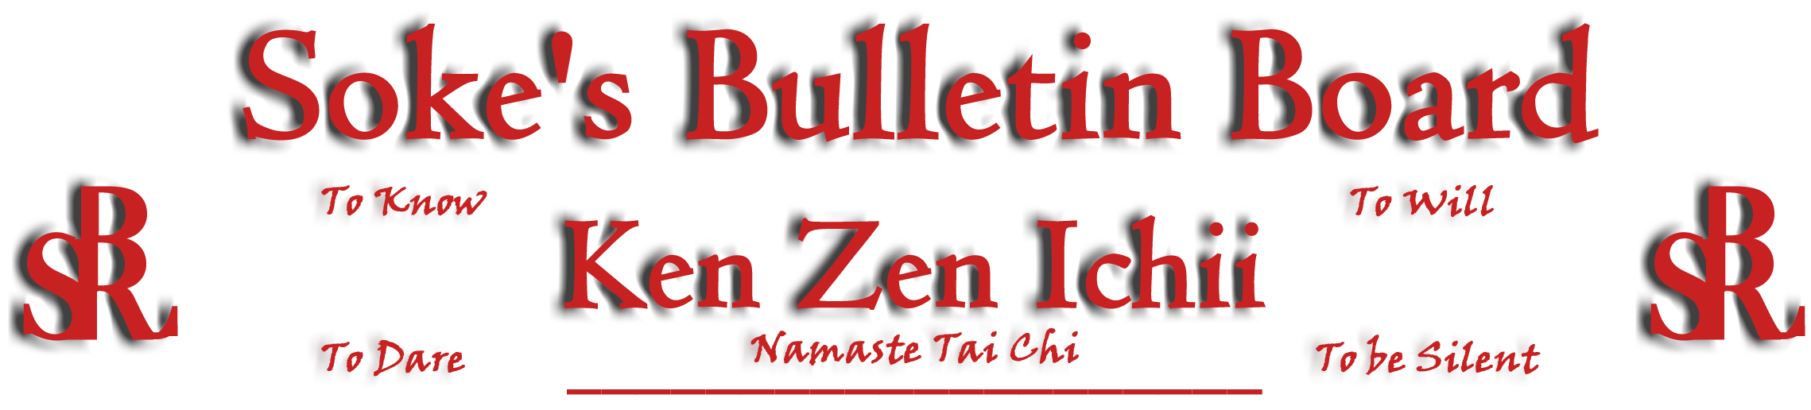
www.kenzenichii.com

December 2009

Promotions
House of Soke II
Congratulations to Sensei Trent Bullock on his promotion to the rank of Yodan
Congratulations to Sensei Steve Kalinoski on his promotion to the rank of Nidan

Two Skies School of Self Defense
Congratulations to Marion Orlando on his promotion to the rank of Yellow Belt

House of Soke
Ous! Be advised that Chris Bennett will be promoted to Sandan on 12/26/09.

I wish everyone good health and peace during the holiday season…Soke

House of Soke II
Congratulations to Sensei’s Trent Bullock and Steve Kalinoski on their well deserved promotions.

Crush Fitness
Sensei JJ Liggera will be testing for 2nd degree Black Belt on Sun, 1/10 at 12:00pm. All are welcome!

Thank you to all the students, parents and family members who attended our 3 year anniversary celebration at Crush Fitness on November 21! Students and black belts held a demonstration which was well attended by family, friends, and community members.

We have gift certificates available for the holidays.

Welcome New Students Kyra Salamone, Victor Salamone, Evan Salamone, Ethan Salamone, Emmett Salamone, Adam Stern, Julia Zarecki, and Jacob Zarecki

BSR Modern Martial Arts School
Kyoshi Montgomery would like to thank all who came to the Aiki Jujitsu Seminar on December 4th and 5th. Please visit the web site www.bsrmma.com for future events.

We would like to welcome new student James Holloway.

Two Skies School of Self Defense
We send holiday greetings to the Ken Zen Ichii family.

Sapphire Dragons
To all the students of the BSR/Ken Zen Ken Ichii karate system, we the students of the Sapphire Dragons, wish everybody a Happy and Prosperous Holiday.

Miscellaneous
Happy birthday to Ken Zen Ichii Grand Master Jerry Watanabe Francisco Hanshi, December 11.

2009 has been a year of happiness, hardships, challenges and solutions. Aren't they all the same? Merry Christmas, Love and Forgiveness keeps us moving forward. Mansfield Kyoshi

KZI NEWSLETTER – December 2009
Page 2 of 2

RECONCEPTUALISING THE MEANING OF DISABILITY: RECONSTITUTING THE SELF ANEW
The school in the United Kingdom continues to grow strong. The membership has increased; the recognition of martial arts in work with learning 'disabled' students has gained acceptance and is supported by a five year research project that is specific to this work. For clarity, the research is the basis of my PhD study to be defended next year. The dissertation will be available to others who wish to write government grants for inclusive work with learning 'disabled' students.

In the 5th year now, the school has promoted seven students to the rank of junior black belt. The test involves half the requirements demanded of all senior black belts, which is quite an accomplishment for learning 'disabled' students. It should be noted that the slab break has been replaced with body board breaks: head, shoulders and thigh, and a final break of a black belt re-breakable board with a technique of the student’s choice. I submit for consideration the inclusion of junior black belts on the linkage section of the website, so they can get the recognition they deserve, as a few of my junior black belts want to teach other learning 'disabled' students; of course the current government will aid them financially and I will offer professional support. On a side note, when senior instructors ask new black belts to teach pee-wee class, do not regret it; the experience is invaluable as it has helped me with my current work. Many thanks Kyoshi Ling!

It is also news worthy that the school hosted its first successful karate tournament this year; the second annual tournament is scheduled for the upcoming year with many more schools taking part. Our students placed 1st, 2nd and third in fighting. Regrettably, they did not do as well in kata, my personal favorite; still, to see them all move together during kata is remarkable.

Kind regards to all,
Sensei Lee

Pearl’s of Wisdom

Two Wolves
One evening an old Cherokee told his grandson about a battle that goes on inside people. He said, "My son, the battle is between two "wolves" inside us all. One is Evil. It is anger, envy, jealousy, sorrow, regret, greed, arrogance, self-pity, guilt, resentment, inferiority, lies, false pride, superiority, and ego. The other is Good. It is joy, peace, love, hope, serenity, humility, kindness, benevolence, empathy, generosity, truth, compassion and faith." The grandson thought about it for a minute and then asked his grandfather: Which wolf wins?" The old Cherokee simply replied, "The one you feed."

Editor’s Notes
Articles for the Ken Zen Ichii website and newsletter are being actively solicited. Anyone who wants to submit an article should contact Sensei Michael Calabrase at mcalabrase@bsrwarriors.com or the editor at Noah_Valle@hotmail.com, (818) 395-0757.

