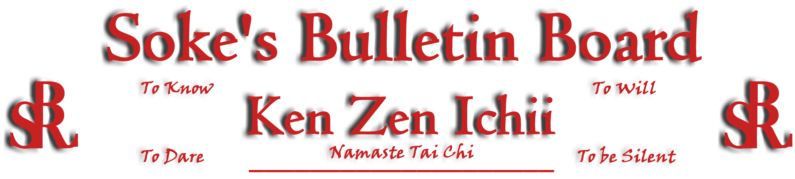
www.kenzenichii.com

October 2009
Promotions
House of Soke
Ous! Be advised that as of September 24, 2009 I shall recognize Vincent Montgomery as Kyoshi within the BSR/KZI system. He is only the seventh to reach this title in 37 years. I wish well on the rest of his journey. Namaste, Soke

House of Soke II
Congratulations to Sensei John Casisa on his promotion to the rank of Godan
Congratulations to Sensei Chris Kelly and Sensei Clive Wilson on their promotions to the rank of Sandan.
Congratulations to Sensei Joshua Ziolkowski and Sensei Joey Brown on their promotions to the rank of Shodan.

Crush Fitness
Congratulations to Mike Onghena and Taylor English on earning the rank of Green Belt

House of Soke II
Thanks to Sensei Casisa and family, the Tomlinson family, and Brian Franklin for their assistance at the House of Soke II booth presented at the Dash for Don.

Kyoshi Leary has accepted a request from Mooresville High School student Amanda Wilson to mentor her through her senior project. The topic is Self Defense. Amanda will spend 15 hours to learn basic techniques and then present a report to the senior project board. Amanda is Sensei Wilson's youngest daughter.

Sensei Wilson has accepted a request from a Mooresville High School student Patrick Flannigan to mentor him through his senior project. Patrick's topic is the health benefits of Brazilian Jiu-Jitsu. Sensei Wilson will expose Patrick to basic grappling techniques that are common between BJJ and KZI.

Judo/Jiujutsu class is now being offered on Saturdays from 10:00 am to noon.

Crush Fitness
Our 3 year anniversary celebration at Crush fitness is coming up soon - more info will be available in our next newsletter.

Welcome new student Danielle Stern. Welcome back Jacob Moore and Justin Moore

It is important that all students have their required patches on their uniforms. Uniforms are incomplete without these patches.
- White belts - BSR/KZI patch on left pocket, American flag patch on right shoulder
- Yellow belts and higher - White dragon patch on left shoulder, KZI patch on back of uniform

Thank you parents! It is the commitment of the parents/grandparents that causes their child to succeed in the martial arts. They are the ones that encourage, support, and are consistent in providing the transportation to and from karate classes.

“Karate is not seasonal and is not a sport. Karate is an art form, a discipline, a way of life.”

BSR Modern Martial Arts School
BSR Modern Martial Arts will be hosting an Aiki-Jujitsu seminar on December 4th and 5th at the House of Soke II. This seminar will feature Grandmaster Velasquez, student of the legendary Moses Powell, who is the head of Atemi Ryu Jujitsu System of Self Defense in North Carolina with more than 35 years of martial arts experience. For more information contact Kyoshi Montgomery at senseibsr@gmail.com.

We congratulate Sensei’s Joshua Ziolkowski and Joey Brown, House of Soke II’s newest Black Belts.

BSRWarriors.Com
The photo gallery is now active on www.BSRWarriors.com we are asking for anyone that has pictures they wish to share (ESPECIALLY the "old school" members) to contribute what they have. We also ask for all black-belts that wish to participate to send a few pics from their tests. Pictures may be sent to mcalabrase@gmail.com or (for those that have already joined the site) uploaded directly in the gallery section. Please check the site often as there will be a lot of content added regularly now that the site is configured.

KZI NEWSLETTER – October 2009
Page 2 of 2
Pearl’s of Wisdom
" Three Tears; one for you memories, one for your dreams, and one for when you share them with me.
' You will always be missed, and never forgotten' Son, Brother, I cried out! This is a hard one."
…Mansfield Kyoshi

Kids and Bullying
Bullying can make kids feel hurt, scared, sick, lonely, embarrassed and sad. Bullies might hit, kick, or push to hurt people, or use words to call names, threaten, tease, or scare them. A bully might say mean things about someone, grab a kid's stuff, make fun of someone, or leave a kid out of the group on purpose. As a parent it’s hard seeing your child go through this. Here are some other strategies to discuss with kids that can help improve the situation and make them feel better.

- Avoid the bully and use the buddy system. Use a different bathroom if a bully is nearby and don't go to your locker when there is nobody around. Make sure you have someone with you so that you're not alone with the bully. Buddy up with a friend on the bus, in the hallways, or at recess — wherever the bully is.
- Hold the anger. It's natural to get upset by the bully, but that's what bullies thrive on. It makes them feel more powerful. Practice reacting by not crying or looking upset. It’s easier said than done and may take a lot of practice, but it's a useful skill to have. One suggestion is to teach kids to wear a "poker face" until they are clear of any danger.
- Act brave, walk away, and ignore the bully. Firmly and clearly tell the bully to stop, then walk away. Practice ways to ignore the hurtful remarks, like acting uninterested. By ignoring the bully, you're showing that you don't care.
- Tell an adult. Teachers, principals, parents, and lunchroom personnel at school can all help stop bullying.
- Talk about it- Talk to someone you trust, such as a guidance counselor, teacher, sibling, or friend. They may offer some helpful suggestions, and even if they can't fix the situation, it may help you feel a little less alone.
- Reaching Out At home you can lessen the impact of the bullying. Encourage your kids to get together with friends that help build their confidence. Help them meet other kids by joining clubs, art or sports programs. And find activities that can help a child feel confident and strong.

Actions Versus Intent

Recently while working with a student after class I suffered a blow that caused what many called “the most spectacular black eye” they had ever seen. It was. It can be seen on my Facebook page and though a month later it can still be faintly seen on me. Now though there are many questions of how this happened, what was going on, and the subsequent actions that came about, none of these is what I wish to discuss here.

The student and I had some discussion regarding the incident but as always we both learned from it. The student swears he had no INTENT to cause the injury and knowing him as I do I believe him. However he also is very competitive. This I believe led to an unconscious battle within himself between his actions and his intent and thereby his control.

In teaching, and this is at any level, I try to always stress that KZI is reality based and that it WORKS. I stress that students should always ASK if they are unsure what a technique does. The ability to injure another person is very real and it would be a shame to do so out of ignorance. Your actions should be governed by the intent in this arena.

How many of us have watched as a student has thrown a technique half hearted and we told him/her to put their spirit into it. Throw it powerfully. I know I have both been told this and now tell others the same. It is part of the growth. However a move now takes on the life you give it. Your intent now rules your action. Is it your intention for light contact? Or is it to damage, cripple, or if necessary kill? Big question.

I have often told my students that when I spar/fight that my actions are exactly the same no matter if I am doing basics or fighting on the street. The difference comes in my intent. The only difference is in how much force I am using to hit someone not any adjustment in technique. I think it is important to stress to students that they be sure of their intent. Because the other side of this is whatever the intent is or was you will have to live with the weight of that decision.

I hope that the community can derive some insight from my experience. In writing I am working to understand my own thought process and in turn hope to learn from any feedback from others…Sensei Joseph Liggera, Sr.

Editor’s Notes
Articles for the Ken Zen Ichii website and newsletter are being actively solicited. Anyone who wants to submit an article should contact Sensei Michael Calabrase at mcalabrase@gmail.com or the editor at Noah_Valle@hotmail.com, (818) 395-0757.

