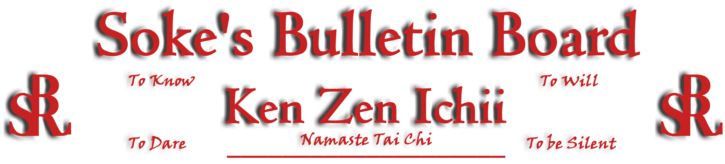
www.kenzenichii.com

April 2009
Promotions
BSR Modern Martial Arts School
Congratulations to Colin Hinkley for his promotion to Yellow Belt.

KZI Warriors.Com
BSRWarriors.com now has a Photo Gallery.. We are waiting to get some more photo's before it's official launch. Please submit any photos you would like to Sensei Calabrase (mcalabrase@gmail.com). You may also include any caption(s) you would like as well. Also all members are encouraged to add their own posts to topics in the forum section. There is now a "Request Topic" section for anyone to suggest a topic they would like to see on the site.

House of Soke II
All is going well.

BSR Modern Martial Arts School
Please visit our website www.bsrmma.com for new schedule and school info.

Welcome new student and NFL star Troy Pelshack.

Two Skies School of Self Defense
All is going well.

Crush Fitness

Welcome new students Kevin Graham, Tyler Madison, and Dylan Madison.

Welcome back Mary Papadopolous.

Congratulations to Sensei Georgie Super on winning 3rd place at the science fair at Poughkeepsie Middle School and Justin English for winning the Chess championship at Arthur S May elementary school 3rd grade.

Students have been asked to bring their musical instruments or sing in karate class. As you know some students are resistant and don't want to play it, or sing in front of others. Students come out on the floor and do a kata and their technique while others watch with no difficulty. Playing an instrument should be no different. Both require practice, focus, discipline and commitment. This is also an opportunity for students to display another of their artistic skills. Congratulations to Brittany Cairns (flute), Morgan Blatz (violin), and Alex Gray (saxophone and recorder) for their musical prowess.

Karate and Fitness
All is going well

KZI California
Congratulations to Sensei Ira Watanabe on the recent birth of his son.

KZI NEWSLETTER – April 2009
Page 2 of 2
Pearl’s of Wisdom
Yesterday is History
Tomorrow is a Mystery
Today is a Gift, that is why they call it the Present.
Now! open it….OS, Mansfield Kyoshi

Remember the five simple rules to be happy:
Free your heart from hatred - Forgive.
Free your mind from worries - Most never happen.
Live simply and appreciate what you have.
Give more.
Expect less

Deja Fu: The feeling that somehow, somewhere, you've been kicked in the head like this before.

A young Samurai warrior stood respectfully before the aged Zen master and said, master, teach me about Heaven and Hell." The master snapped his head up in disgust and said," Why, I doubt that you could even learn to keep your sword from rusting! You ignorant fool! How dare you suppose that you could understand anything I might have to say?" The old man went on and on, becoming even more insulting, while the young swordsman surprise turned to confusion and then to hot anger, rising by the moment. Master or no master, who can insult a Samurai and live? At last, with teeth clenched and blood nearly boiling in fury, the warrior blindly drew his sword and prepared to end the old mans sharp tongue and life in one furious stroke. But at that moment the master looked straight into his eyes and said gently, "that's Hell"

You know you are a KZI Karate animal when:
1. Three words come to mind "Pain is joy.”
2. When all your injuries heal, you go through withdrawals.
3. You tie your bathrobe belt in a square knot then check to make sure the ends are completely even.
4. You trip, go into a roll and come up in a fighting stance - in church.
5. You accept change from the cashier using a perfect knife hand with the thumb carefully tucked in.
6. You find yourself practicing cane techniques in miniature with your pencil during dull meetings.
7. You bow going into and out of the bathroom.

Why KZI is not a tournament oriented school

KZI karate is a reality-based martial arts system that holds the standard of “keeping it real” and taking what one learns and applying it in a realistic manner when confronted. Sport or point karate base their fight on the point system. Whoever gets the most points wins. Reality-based karate is not a point fight, so we don’t train that way. Some of the kata techniques in tournaments can be seen as “pretty” and theatrical, and require a level of athleticism, but are not based on realistic application; moves and kia’s are based on getting the attention of the judges. If a student brings in the reality of the martial arts to a tournament, they usually get disqualified. Healthy competition in tournaments facilitates team camaraderie and spirit and has its place in all competitive sports. Sport karate has its place in this arena if that is what one is seeking. KZI karate is not a sport but an art form. It is not something you do, but some thing you eventually become.

