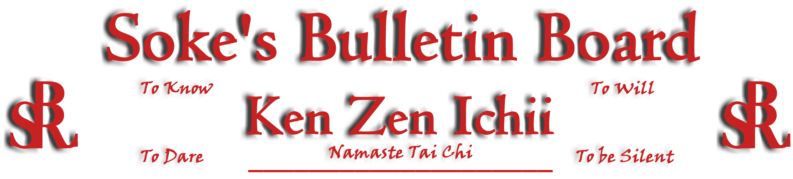
www.kenzenichii.com

January 2009
Promotions
Crush Fitness
Congratulations to Justin Acampora on earning the rank of Green Belt

KZI California
Congratulations to Abegail Romano on earning the rank of Green Belt
Congratulations to Christina Francisco on earning the rank of Green Belt

KZI Website
The BSRWarriors site is now live!!! Site features include a discussion/forum board, chat client, and a photo gallery. Anyone with photos that you would like to post should send them to Sensei Michael Calabrase at mcalabrase@bsrwarriors.com

House of Soke
Ous! Martial Arts training absent of reflection is just exercise. Conversation absent of trust is just chatter. Your New Year is always NOW. Namaste, Soke

House of Soke II
We will be having an upcoming pizza party for the dojo – hope everyone can attend. Details are forthcoming.

Thank you Kyoshi Mansfield on your December seminar on principles that are essential to all Martial Arts.

Thanks to all students for a great 2008, and looking forward to a better 2009.

Two Skies School of Self Defense
Wishes every one good health and prosperity for the New Year and looking forward to continued growth and development.

We have made the transition to 60 Welcher Avenue Peekskill, NY 10566

Crush Fitness
I hope Santa filled your homes with peace and blessings, and this New Year brings you much happiness and new beginnings.

Sensei Baker and Sensei Underwood are now offering 3 hour Women’s self defense workshops at your business or home on the dates and times of your choosing. In this interactive course you will learn:
- Basic behaviors and attitudes that will increase your awareness
- How to get out of potentially dangerous situations
- Common lures of an attacker/acquaintance
- Realistic self defense techniques from standing and ground positions

Books worth reading: “The Gift of Fear” -Gavin Debecker and “The Power of Body Language” -Tonya Reiman

BSR Modern Martial Arts School
All is going well.

Karate and Fitness
All is going well
KZI NEWSLETTER – January 2009
Page 2 of 2
Pearl’s of Wisdom
The four agreements by Don Miguel Ruiz "A Toltec wisdom" book
- Be impeccable with your word.
- Don't take anything personally
- Don't make assumptions
- Always do your best

"Intuition is knowing without knowing why you know"…Sensei Baker

Memories do not lie.
Share the good one. OS Mansfield Kyoshi

Doing your best is a matter of doing… Shihan Harry Parker, President, www.twoskiesinc.com

A Call for a Thematic Analysis, by Sensei Larry Lee

Hermeneutically speaking, some philologists, Dilthey included, held that a “psychological interpretation” of the meaning of words could be gained from using what is known as “Dialogue Proper”. Using the “Hermeneutic Circle” method, a reader could not only discern the meaning of the written word, but he or she could, using a higher level of “intuitiveness”, know the writer’s mind.

What is the meaning of BSR? And can we know the meaning that was intended by Soke Dwight Childress when he elected to name our school accordingly? Whilst the argument could be had, I prefer instead to highlight what constructionists bring to the discussion, as their thinking is more akin to the point I wish to make. Perhaps each of us has already constructed our own meaning and understanding of BSR. But I ask you to pause and give the matter some consideration. What does brotherhood mean to you? What does self-development mean to you? And what, I dare ask, does respect mean to you? These questions may seem unimportant, but I assure you they can lead to much contemplation. Some will be incline to say I respect him or her, but their understanding of respect and the meaning they intend is not what the other person recognizes as respect. In this instance one is showing respect within his or her conceptualization of respect, but the other does not see it in the same way. Another person says I am about self-development, but their focus is physical, another mental and a third spiritual; still, their definition may differ one from the other. And brotherhood, do we share the same understanding of this term? It is very doubtful! Oh, and what of sisterhood? A question raised by some women in Europe.

Perhaps a thematic analysis would help us to explore the meaning we assign to the terms we use to describe ourselves and our endeavors in regard to the martial arts. What’s in a name; um, you tell me! Let the editor of the newsletter know what these terms mean to you and when all the responses are in, we can look for common themes, patterns, etc. Perhaps, if nothing else, we will each have a clearer understanding and greater appreciation of BSR! Indeed we will find that there remains something, a higher level of conceptualization that has yet to be fully achieved.

Editor’s Notes
Articles for the Ken Zen Ichii website are being actively solicited. Anyone who wants to submit an article should contact Sensei Michael Calabrase at mcalabrase@gmail.com or the editor at Noah_Valle@hotmail.com, (818) 395-0757.

