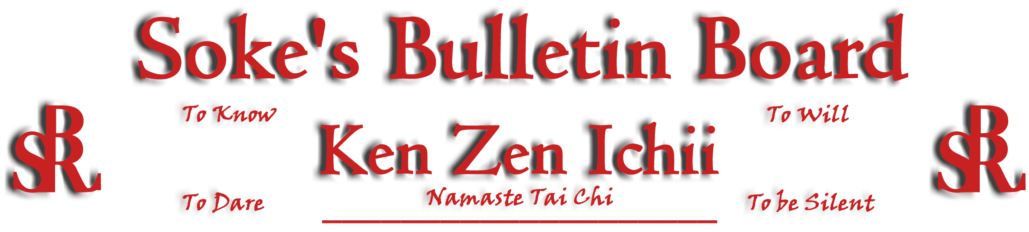
www.kenzenichii.com

November 2008
Promotions
BSR Modern Martial Arts School
Congratulations to Sensei El Amur on his promotion to the rank of Shodan

House of Soke II
Congratulations to Tyler Smith on the promotion to the rank of Yellow Belt.

Crush Fitness
Congratulations to Pierson Bisceglia on earning the rank of Brown Belt
Congratulations to Kaitlyn Zhao on earning the rank of Yellow Belt

House of Soke
Sensei El has stood in the fire - WELCOME.

Kyoshi Mansfield teaches principles that are essential to all Martial Arts. Don't miss his seminar on December 4th from 7:30 to 8:30 pm at the House of Soke II. This seminar will be open to all current and former BSR/KZI students.

Work Explore and Discover. Happy holidays to all…Soke.

House of Soke II
Since the weather did not allow for the annual picnic, HOS II is planning a pizza party for the school. Details are forthcoming

Two Skies School of Self Defense
The Two Skies School of Self Defense is relocating to 60 Welcher Avenue Peekskill, NY 10566. Sensei Parker will be resuming the Title Shihan of the Four Winds System of Self Defense effective November 1st 2008. The promotion was granted on October 11, 2006 from his first instructor the late Master Gregory Jaco of Chicago.

Crush Fitness
Georgie Super will be testing for Black Belt on Sunday, November 16th at 12:00pm.There will be no Sunday karate class that day.

Thank you!! To all of the parents, families, friends, students and Sensei’s who attended, participated and contributed to our 2 year anniversary at Crush Fitness.

There will be a women’s self defense course on Sunday Nov 23rd from 12-3pm. Participants will learn:

- Basic behaviors and attitudes that will increase your awareness
- How to get out of potentially dangerous situations
- Common lures of an attacker
- Realistic self defense techniques from standing and ground situations
- How to release yourself from chokes and holds

Sensei Baker and Sensei Liggera and Sensei Long will be teaching this course which has a fee of $50 (free to adult and junior karate students).
KZI NEWSLETTER – November 2008
Page 2 of 2

BSR Modern Martial Arts School
Welcome back Sheldon Jackson and congratulations on the birth of his son.

Congratulations to Sensei El Amur for an outstanding Black Belt Test. We would like to also thank every one that supported us on our 1st Black Best Test and shared this memorable experience. It was enlightening.

We will be closed for the Thanksgiving Holiday, but private lessons may be available.

Shihan Montgomery attended a Memorial Seminar for Moses Powell in Miami, FL on November 6-8.

A special thanks goes out to Soke Farrell of the AKKA for the seminar invitation hosted by ATF Agents on Tactical Assessment and Reaction.

The Multiple Opponent Seminar/Black Belt Test is now on sale.

KZI California
We have just embarked on our most ambitious karate program ever. Our fall session now has 36 students participating, ranging from kindergarten to 8th grade. Many thanks to Sensei LaFond for helping teach with this program.

Welcome to the following new and returning students:

Michael Aristov, Christopher Sanchez, Nicholas Harris, Abigail Romano, Jose Lambarr, Alicia Lambarr, Maria Campo, Alyssa Camacho, Sean Thierring, Sean Hovland, Angelo Luis Hernandez, Celeste Amaya, Patrick Gregory, Nicholetta Sarkissian, Anthony Fadly, Catalina Alonso, Franco Alonso, Leonardo Sarkissian, Jon Romano, Andy Hovland, Mikayla Giden, Andre Zambrano, Conner Smith, James Smith, Emily Thierring, Reagan Harris, Lulu Aguirre, Dylan Diangco, Michael Fadly, Mary Fadly, Joshua Malone, Andrew Schneider, Alyssa Gomez, Andrew Gomez, Leonardo Hernandez, James Romano
Pearl’s of Wisdom by Sensei Larry L. Lee (Part 2 of 2)

The quote contains two words that I believe are necessary to define before articulating any possible meaning. The first is beast and it means a large wild animal; a brutal or uncivilized person or savage nature or characteristics (Collins Dictionary). The picture of the large beast and the subtle suggestion of an animal tamer could lead one to mistakenly focus on the large animal (basic assumption of mine, and a previous mistake of mine as well), yet the latter two descriptions provides clues to the intended application. The second word, ignorance, means lack of knowledge or education. So, given the quote, the lack of knowledge pertains to something absence in the mind. Again, situating the meaning or directing one’s focus to the author’s intended message.

Although it is a basic assumption that I espouse, ignorance is a deliberate state; meaning the truth of a matter is known to each of us intuitively, but we are faced with making a choice – either accept, know and embrace what is right or true, or wallow in our ignorance, gradually becoming a beast, ferocious in our attempts to defend our attempts, even when we know they are utterly wrong. The journey down the road of “…ignorance roaming in the jungles of the mind” can we travelled when we willfully, knowingly decide to operate from defensive stances: Blame, Lie, Avoid, Minimize and Excuses.

A word of caution is offered at this conjecture because of my personal experience. Before allowing the inner beast to snatch from you my intended message, be brave enough to consider this test: Consider any situation that has grieved you sorely; then picture how the entire scenario would be different had you not operated using anyone of the defensive stances. The inclination will be to look externally at others for their contribution to the situation, but be strong enough to see only your contribution to the situation. Then ask yourself, how different would it have been had you not conducted yourself defensively? I believe you will find that it would have been entirely different.

Whilst my explanation may be far from what was originally intended, I offer the following: the defensive stances represent the “beast of ignorance roaming in the jungles of the mind.” (next month – the source of the quote)

