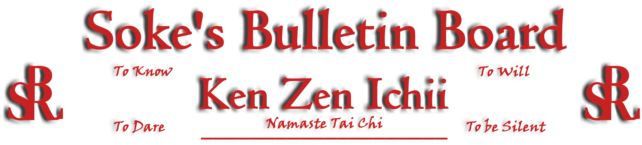
www.kenzenichii.com

July 2008

Promotions
House of Soke II
Congratulations to Sensei Clive Wilson on his promotion to the rank of Nidan
Derwen College Warriors (Great Britain)
Congratulations to the following students on their promotions to the rank of Junior Black Belts: Sensei Rebecca Erickson, Sensei Malik Jama, and Sensei Scott Langley
Crush Fitness
Congratulations to Elizabeth Bellissimo on earning the rank of Yellow Belt

Ken Zen Ichii Reunion
A reunion of the various Ken Zen Ichii Dojo’s is scheduled to coincide with the upcoming Black Belt Test scheduled for the weekend of September 6th and 7th, 2008 at the House of Soke II in Charlotte, NC. All members within the Ken Zen Ichii family are invited to attend - we already have firm commitments from several members from across the US. This weekend will be filled with several seminars to share knowledge and experiences with each other and to strengthen the bonds and ties between us. Please join us for this celebration!! If you are interested in joining us or doing a seminar during this event, please coordinate it with Sensei Scott Dellinger at Noah_Valle@hotmail.com, (818) 295-0757.

House of Soke II
- Welcome back new students Olivia Eichenburger (Pee Wees) and Robert Malvacker (Juniors)
- Congratulations to Nigel Edwards on his graduation from The Ohio State University, Class of 2008.
- Ray Hutchins will be testing for his Black Belt on September 7, 2008.
- The House of Soke II annual picnic is scheduled for September 27, 2008 at 11:00 am. The location will be the Blythe Landings Park in Huntersville. Contact Sensei John Casisa or Shihan Nathan Brown for directions or additional questions.

BSR Modern Martial Arts School
BSR Modern Martial Arts will host a seminar based on knowledge of the martial arts being lost by the popularity of UFC style training. We will be joined by several martial artists from different styles of the arts. Our aim is to show how to get back to the root of the arts. In turn, we hope to reinstall a fresh approach to the art of strikers. This seminar will be held at Ray's Splash Planet (the gym) 215 Sycamore St in Charlotte, NC. This event will be held on 7/25/2008 @ 6:30 pm. Gi's must be worn to participate. All KZI members are welcome to attend and the event will be recorded for a KZI DVD. Guest speakers will include: Sifu Amur El, Shihan Anthony Leary, Sensei Vincent Montgomery, Sibok Fulton Cuthbertson with a special appearance by the Soke Dwight Childress. For more info please contact Sensei Vincent Montgomery @ (704)837-6101 or by e-mail senseibsr@gmail.com.

BSR MMA would like to welcome our newest student Sheldon Jackson.

Congratulations to Chuck Calebro on the release of his band, Black Ritual's new album 1000 Yard Stare and voted one of the top metal band in the Carolina's by The Creative Loafing news paper. Album sold in all east coast Best Buys!
Two Skies School of Self Defense
Christina Caragine will be testing for Shodan Black Belt in July 2008. If successful, she will be the first to accomplish this goal under this dojo.

Derwen College Warriors (Great Britain)
Our blackbelt test candidates are labeled as disabled (e.g. Aspergers, Autism, Downs Syndrome, etc.). It is wonderful to know that the system has expanded to include a specialized behavioral program that is research-based and will soon be published in a well-known journal (GAP). These candidates, as part of the requirement to pass the test, had to complete 20 modules/chapters that are specific to anger management, conflict resolutions, problem solving, anatomy of anger, effective communication in interpersonal relationships, and communication outside of the five defensive stances. This is a wonderful accomplishment given they are not suppose to possess the cognitive ability to internalize and generalize these concepts; yet, we have video recorded evidence over a three year period that demonstrates that they can. Congratulations to Junior Black Belt Sensei’s Rebecca Erickson, Malik Jama, and Scott Langley for their accomplishment!!!

