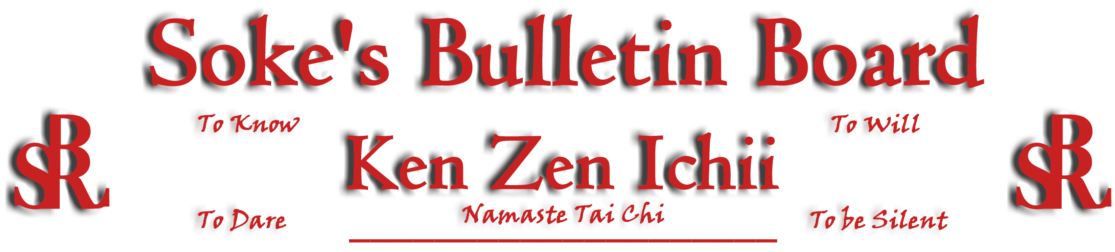
www.kenzenichii.com

April 2008

Promotions

House of Soke
Be advised that Sensei John Dugger the first BSR black belt promoted by Soke has been granted the rank of Sandan. He was a pioneer for all that followed.

Crush Fitness
Congratulations to Theo Kryou on receiving the rank of Green Belt
Congratulations to David English on receiving the rank of Green Belt
Congratulations to Terri Keeley on receiving the rank of Green Belt

House of Soke II
Congratulations to Joshua Tomlinson on receiving the rank of Brown Belt
Congratulations to Ahmad Charles on receiving the rank of Brown Belt
Congratulations to Hunter Butler on receiving the rank of Yellow Belt
Congratulations to Duncan Jennings on receiving the rank of Yellow Belt
Congratulations to Maverick Holmes on receiving the rank of Yellow Belt
Congratulations to Jordan Curbeam on receiving the rank of Yellow Belt
House of Soke II
The Black Belt Test scheduled for 04-13-2008 has been postponed until further notice.
Welcome to the new pee wee's: Ante Zrnich, Preston Kelly, and Harrison Joyner

Crush Fitness
Alex Onghena will be testing for his Black Belt on Sunday, April 6th at 12:00pm

Brittany Cairns will be testing for Green Belt on April 4th.

Welcome new students Tiffany Bellissimo and Alexander Gray

Before class starts and students are in meditation, there is to be no talking in the dojo.

Sapphire Dragons
All is going well.

BSR Silent Tigers
All is going well.

KZI California
All is going well.

Pearl’s of Wisdom
Two Zen monks were walking down the road.
First monk says: "These pine trees are magnificent."
The second monk slaps him across the face.
First monk: "Why did you do that?"
"I'm a Zen monk so I can get away with all kinds of weird stuff like that."

Editor’s Notes
Articles for the Ken Zen Ichii website are being actively solicited. Anyone who wants to submit an article should contact Sensei Michael Calabrase at mcalabrase@gmail.com or the editor at Noah_Valle@hotmail.com, (818) 395-0757.

