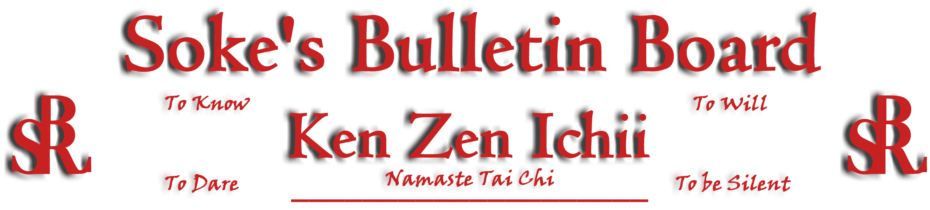
www.kenzenichii.com

January 2008

Promotions

House of Soke
Congratulations to Sensei Nate Brown who on December 21 was promoted to the position of Shihan, a man of integrity.

House of Soke II
Congratulations to Raymond Hutchinson on the promotion to Brown Belt
Congratulations to Joshua Ziolokowski on the promotion to Brown Belt
Congratulations to Preston Hagman on the promotion to Green Belt

Crush Fitness
Congratulation to Sensei Thaje Jeanty for achieving the rank of Shodan on Sunday December 16.

Sapphire Dragons
Congratulations to Nicholas & Nicole Visbeck on their promotion to Yellow Belt
House of Soke II
The "Hopewell High School" demonstration went very well. Special thanks to the following participants: Sensei Debbie Wilkinson, Sensei Chris Kelly, Marilyn Kelly and Joshua Ziolokowski.
The House of Soke II would like to thank everyone for a great holiday and 2007. Next year in 2008 will bring us all opportunities!
Crush Fitness
If students don’t practice, forget basic techniques and have not demonstrated their skill at their rank level they are not moved to the next rank level or stripe, regardless of how long they have been in the karate program. Behavior at home and in school is most important. This is to insure that we keep our karate program a quality one.

Sensei Liggera teaches grappling class. Grappling refers to the gripping, handling and controlling of an opponent without the use of strikes. Grappling is an important part of both ground and standing fighting. Grappling is a mode of fighting used by many different martial arts around the world. It is not a distinct martial art, but rather a collection of techniques and strategies aimed at defeating an opponent, these can be subdivided into throws, joint and pinning techniques.

Sapphire Dragons
Kyoshi Ling will be visiting Sensei Baker on January 11, 2008 at 8:00 P.M. at Crush Fitness.
Regards and best wishes to you and all of the rest of the Karate Ka's for a safe and happy holidays.

Poughkeepsie YMCA
All is going well.

Pearl’s of Wisdom
"We are all products of our own experiences and interpretations. We each shoulder our own weight. We are who we are…but we become less when we expect others to shoulder our weight or cloud their experiences and interpretations."

“From a healed, peaceful heart, humility is born; from humility, a willingness to listen to others is born; from a willingness to listen to others, mutual understanding is born; and from mutual understanding, a peaceful society will be born.”

