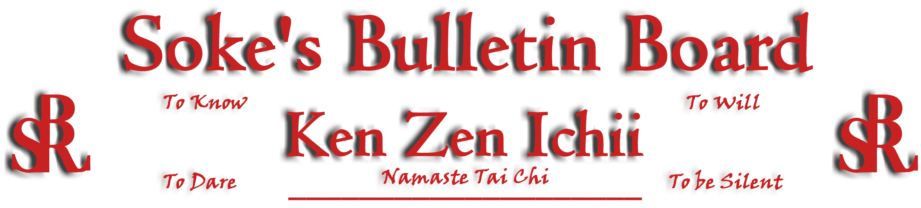
www.kenzenichii.com

July 2007

Promotions

House of Soke II
Congratulations to Sensei Chris Kelly on his promotion to Shodan

Two Skies School of Self Defense
Congratulations to Mya Lipscomb and Jovanny Elliot on their promotion to Juinor Orange Belt.

House of Soke
House of Soke recommends The Book of Martial Power by Sifu Steven Pearlman (www.singlestepproductions.com) which accelerates the EVOLUTION of Martial Arts and angers the false Buda's around the world. This book is recommended to all KZI Black Belts.

House of Soke II
Shihan Leary is hosting a grappling class on Sundays @ 3:00 pm.

Welcome back Amur El.

Crush Fitness
Lydia Francese will be testing for Black Belt on Sunday, July 29th at 12:00pm

Welcome new students Joey Pires and David English

Having safe friends is one of the best protections against bullying. Learning how to judge when a friend is safe or unsafe is a major life skill.

Thank you Sensei Pelish (from the KZI school when it was held on Main Street in Poughkeepsie) for your positive energy and outlook. It is an added presence in the dojo.

KZI California
Congratulations to Manvel Gamburyan on making the finals of the Ultimate Fighter. One of the Dooms of a True Warrior is the failure of the Body despite the strength of the Spirit.

Two Skies School of Self Defense

The Two Skies School of Self Defense’s new website is www.twoskiesinc.com.

Sensei Parker would like to recognize Gabe Levinson and Christina Caragine on their promotion to 3rd Degree Brown Belt. We would also like to welcome Dominic Cincotta to the system.

The Two Skies School extends its gratitude to Sensei Baker and students and Sensei Pelish on their visit and support. We hope to become more active in extending opportunities to others in the system and providing our support overall.

Pearl’s of Wisdom
When you acquire information and Knowledge from a messenger be aware that careful discernment and reflection are essential. Forensic bias contaminates and is always imprinted with the knowledge in spite of good intentions. The conversion process is accomplished by WORK not conversation. Namaste, Soke

