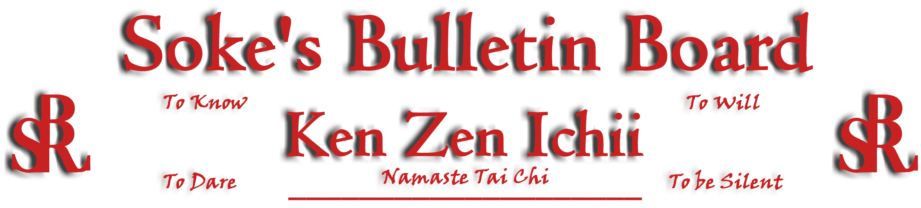
www.kenzenichii.com

May 2007
Promotions

House of Soke
Congratulations Sensei Gloria Baker on your new rank of Yodan and Sensei Muhammad Shamsiddeen to on your promotion to Nidan
House of Soke II
Congratulations to Scott Tomlinson and Bonnie Lee on earning the rank of Green Belt
Congratulations to Lynn Tran and Marissa Curry on earning the rank of Yellow Belt
Crush Fitness
Congratulations to Steven Puchkoff on earning the rank of Black Belt
Congratulations to Jacob Moore on earning the rank of Green Belt

House of Soke
I enjoyed the trip to NY!!

House of Soke II
There will be a Tai Chi demonstration and a Self-Defense Seminar on May 19, 2007 from 10:00 am until noon. We will be putting the day’s events on video. It is an important opportunity for everyone to participate.

A Black Belt Test for Clive Wilson and Debra Wilkinson is scheduled for May 20, 2007. Lunch will follow afterwards at Prime Steakhouse.

Chris Kelly will be testing for his Black Belt on Sunday, June 27, 2007.

Kathy Leahy's Black Belt test has been postponed until further notice due to injury.

Special announcement: Kristin Henderson is in her 1st year of college and is doing extremely well. Courtney Henderson has become very proficient with horse riding.

Crush Fitness
Thank you to everyone for coming and supporting the karate program and welcoming Soke to the dojo. Thank you Kyoshi Arnold and Kyoshi Mansfield for attending.

Anthony Scott will be testing for Black Belt on Sunday, May 20th at 12:00pm. Garrett Greenstein will be testing for Green Belt on Saturday, May 12th at 12:30pm. Brittany Cairns will be testing for Yellow Belt on Friday, May 4th at 5:00pm

Welcome back Sensei Rachel Puchkoff. We wish you a speedy recovery with your shoulder surgery.

A big thank you to all for a successful 6 months at Crush Fitness!!

Welcome new students Sean Lyder and Chiara Cassone

KZI California
Sensei Manuel Martinez will be coordinating a reunion of Ken Zen Ichii students in California on Saturday, May 19. Please contact him at 805-889-4124 if you are interested in attending.

Two Skies School of Self Defense

The Two Skies School of Self Defense would like to honor the Soke for his tireless dedication to the development of both students and instructors. With humility and respect we are grateful for the commitment he posses recognizing that it is also our individual and collective duty to keep the system alive.

Pearl’s of Wisdom
“We do not write the script and we always expect more of people than they can give. Remember: I know you want me to do it the way YOU would do it if you were ME.” Soke

One ultimate lesson- When the Master fails it creates several opportunities to GROW as a human being and one opportunity to become STUCK. The choice is to be made by master and student...Namaste, Soke

