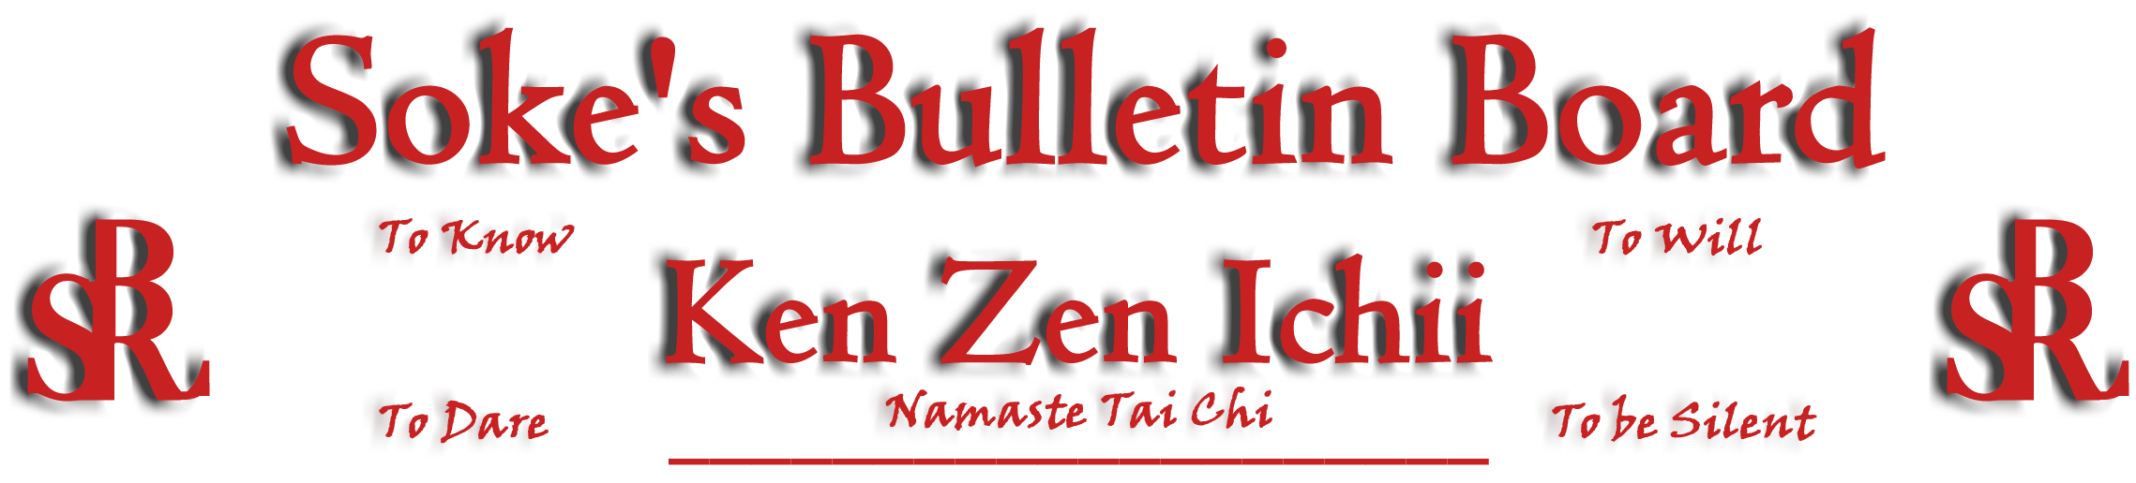
www.kenzenichii.com

August 2006

Welcome New Sensei
Healthy Kick congratulates our newest Sensei India Pantin on earning her Black Belt on July 23, 2006!!!

Promotions

House of Soke
For eight years of diligent loyalty, service and friendship, I have promoted Mr. George Bostic to Honorary Shodan…Soke

House of Soke II
Deen Charles has been promoted to Yellow Belt
Lina D. Charles has been promoted to Yellow Belt
Ahmad Charles has been promoted to Yellow Belt

Healthy Kick
Bill Moloney has been promoted to Green Belt
Molly Murray has been promoted to Yellow Belt

House of Soke II
Sensei Vince Montgomery and Sensei Nate Brown held an excellent seminar on June 29, 2006 titled “The Moment.”

Congratulations to all participants in the Juniors condition class.

Welcome to new students Zane Flowers, Aislinn and Dalton Walcott.

All is going well at Salem Summer Fun Camp and Salem Summer Fun Camp at the Lake instructed by Sensei Montgomery.

Healthy Kick

A Black Belt test will be held for Victoria Santos on August 6, 2006

BSR Silent Tigers

Sensei Howard is reactivating himself after major tendon and muscle surgery and has his new dojo up and running.

Two Skies School of Self Defense

Two Skies School of Self Defense welcomes new student Aaron Dimmie.

Poughkeepsie YMCA
Sensei Bradshaw is doing well.

Kyoshi Ling’s 4th of July cookout was a success. Both he and his family are doing well.

KZI California
All is going well.

Pearls of Wisdom
“Never confuse a single defeat with a final defeat.” Sensei Caraway

