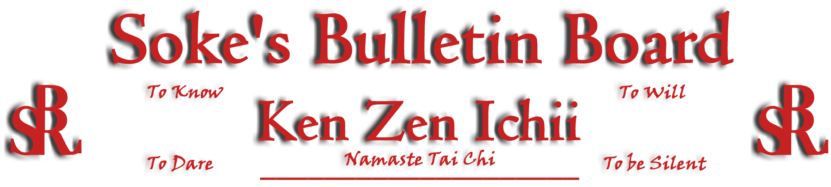
www.kenzenichii.com

August 2005

Farewell Notice From Soke
There are various reasons that cause the communication element of relationships to end (death, ethical, ideology differences, etc) but the influences that we have upon each other will remain and for that I am grateful. The dojo located in Huntersville NC previously known as The House of Soke is now The House of Soke II. Starting on September 1, I will not have input concerning the daily decisions of business or KZI affairs. I will once again become an independent agent available for Martial Art lectures, seminars, select promotions, and sales of intellectual property. Of course social visits are always welcome ☺ Because of past services rendered, the monthly newsletter "Soke's Bulletin" is now under the sole direction of Sensei Scott Dellinger and he will assume complete and full responsibility for its content and intentions. I look forward to his continued excellence. The domain WWW.KENZENICHII.COM which is registered to Sensei Anthony Leary will be available to all KZI members in good standing. I will not designate a successor to the system. I do wish everyone success. To Know, To Dare, To Will, To Be Silent -Eternal Student Dwight Childress

Black Belt Test
A black belt test has been scheduled for Trent Bullock and Tim Wesselman on Sunday, August 7. All Ken Zen Ichii students and black belts are invited to attend.

Promotions

Healthy Kick: Pierson Bisceglia has been promoted to Yellow Belt
Alexandra Tse has been promoted to Yellow Belt
Joey Serensics has been promoted to Yellow Belt
Christopher Burress has been promoted to Yellow Belt

House of Soke
- Congratulations and best wishes to Jennifer Underwood for your pending baby due to arrive August 22nd.
- We mourn the passing of Mr. Moore. Thank you for granting us the opportunity to open our dojo on your family’s land.
- The Annual Dojo Picnic has been tentatively scheduled for September 17. All members, families, and guests are welcome to attend.
- Thank you to everyone who helped with the recent Birkdale martial arts demonstrations, especially Debbie, Hannah, Matt, and Chris.
- Welcome new student Mrs. Debra Griffith.
- Scott Dellinger will be conducting a sword seminar on Friday, August 5 from 7 pm to 9 pm. All juniors and adults are invited to attend. Please let Sensei Leary know if you need to order a bokken.
- Ous! We wish Kyoshi Norman Tillery and Ms Patricia Ann Mohan enduring peace and prosperity when they exchange marriage vows on 8/7/05.
- The new email address for the House of Soke II is kzihs2@gmail.com. The personal email address for Soke Dwight Childress is changing to sokekzi@carolina.rr.com Please refrain from using the old email address of sokekzi@att.net as this will be discontinued.

Healthy Kick
Congratulations and best wishes to Kyoshi Tillery on his marriage.

Sensei Shamsuddeen will be hosting a Concepts and Applications for Proper Growth and Development series of classes which will run through August 12.

BSR Silent Tigers
I will be re-opening my dojo have a new contact number which is (845) 795-5328.

Poughkeepsie YMCA
Effective August 1st, classes will resume at 7 pm every Monday.

KZI - California
Welcome back, Sensei Will Prosser from your tsunami disaster relief efforts in Sri Lanka. We also hope that your mother recovers from her illness.

SokeVision
“I am what I am and that is all that I is.”…Popeye.

“Whatever we had, we had!!!!”…Barry White

