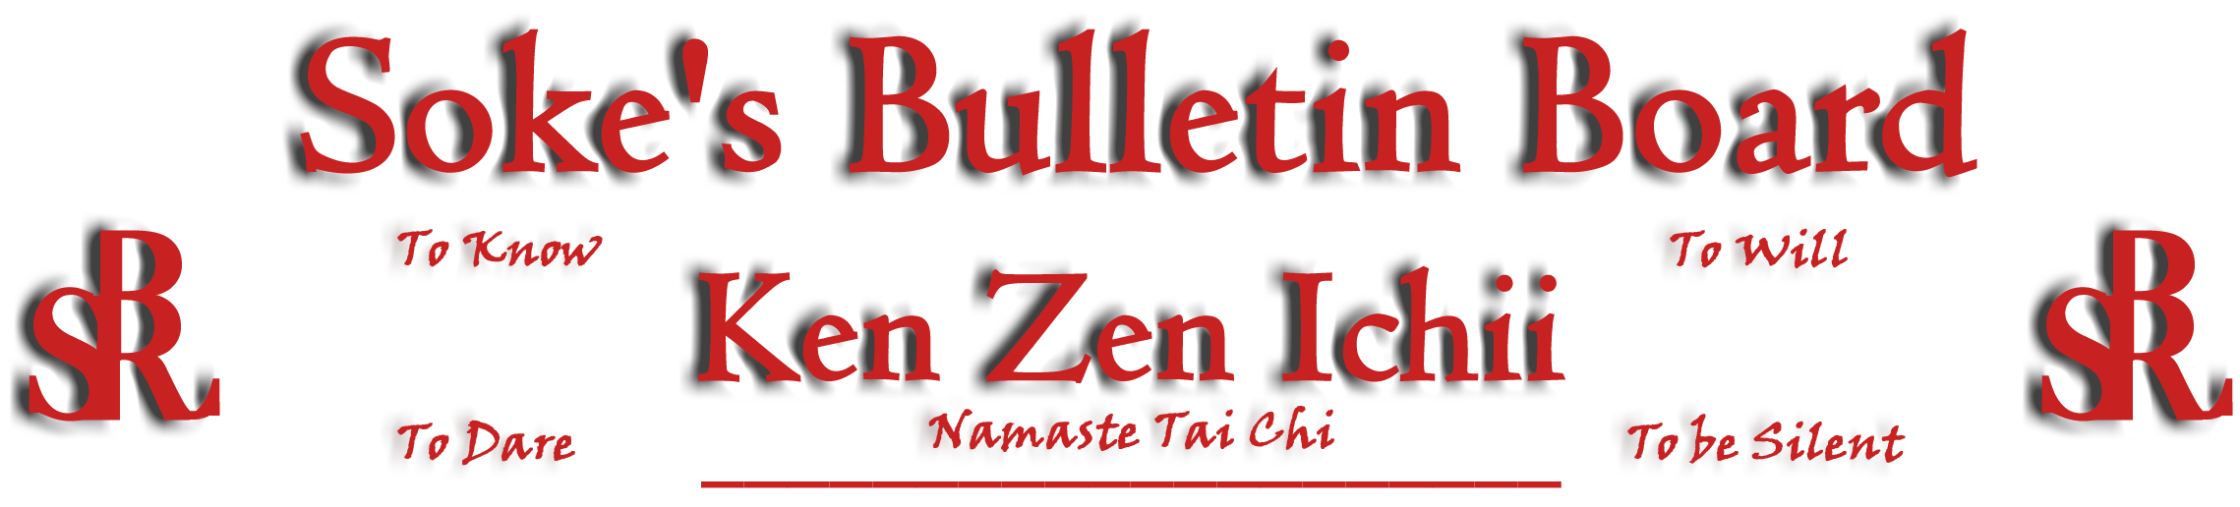
www.kenzenichii.com

June 2005

Special Notes
Thank you all for the love, respect in / out of the dojo. A true Way of Life. All the open minds made my seminar take off. My teaching is like coals of a fire: when the right wood is placed, it takes off. You were my wood.
OS… Kyoshi Joe Mansfield

Promotions

House of Soke: Marshall Shamsiddeen has been promoted to Yodan Black Belt
Vincent Montgomery has been promoted to Yodan Black Belt and 4th Level Namaste Tai Chi Instructor
Paris Nile Childress has been promoted to Sandan Black Belt
Tony Little has been promoted to Nidan Black Belt
Loren Gray has been promoted to Shodan Black Belt
Matt Ferry has been promoted to Brown Belt
Timothy Caulkins has been promoted to Yellow Belt

Healthy Kick: Brendan Long has been promoted to Brown Belt
Dante Harris has been promoted to Green Belt
Michael Dwyer has been promoted to Yellow Belt
Cloe Shan has been promoted to Yellow Belt
Quiante Woods has been promoted to Yellow belt

House of Soke
- The seminar conducted by Soke (New and Incomplete) was well attended.
- Thank you Sensei Tony Little (et all) for the timely and excellent new Dojo sign.
- Our prayers go out to the entire Bostic family as Sue Bostic and George Bostic continue their struggles with health related issues.
- Soke enjoyed his visit and counseling with the New York area Black Belts.
- Soke has recognized Sensei Mike Calabrase for his Discipline of Loyalty to Ken Zen Ichii.
- There has been a meeting with all Yodans. If you have interest, contact me for debriefing.
- Congratulations to Huyen and Sensei Hoang Le on their engagement.
- Thank you to Sensei Tony Little on his verse entitled “This House”.
- Congratulations to Sensei Nigel Edwards for completing High School and best wishes as he continues his studies at Ohio State.
- There will be a Blackbelt Test on August 7th for potential candidates Trenton Bullock and Tim Wesselman.
- We appreciate the visit by Sensei Dellinger.
- Dan, Laura, and Kira Kanemori will be visiting the House of Soke on Saturday, June 18.
- Welcome new students Richchelle Price, Yasmeen Price, and Ethan Knight.

Healthy Kick
All is going well.

Poughkeepsie YMCA
All is going well.

KZI - California
All is going well.

SokeVision
In the land of the blind, the one eyed man is King. In the land of sight, the one eyed man with courage and integrity can still be King. (Internal Vision is always paramount).

