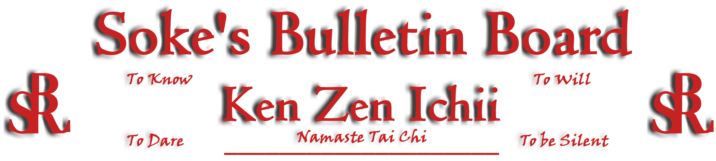
www.kenzenichii.com

May 2005

AWESOME!!!
Welcome peaceful warrior, Loren Gray - this was my last test (Soke). Many thanks to the following out of town guests and visitors who participated to complete this wonderful event: Kyoshi Arnold, Kyoshi Mansfield (Ryukyu Kempo), Kyoshi Bennett (Goju-ryu), Sensei Scott Dellinger, Sensei Marshal Shamsiddeen, Sensei Loren Bellamy, Sensei Harry Parker, Sensei Paris Childress, Sensei Mohammad Shamsiddeen, and Sensei Tyrone James (Goju-ryu).

Promotions

House of Soke: Kathy Leahy has been promoted to Green Belt
Debbie Wilkinson has been promoted to Green Belt
John Sheehan has been promoted to Yellow Belt

Healthy Kick: Melissa Bostjancic has been promoted to Green Belt
Ricky Hyland has been promoted to Green Belt
Lena Chin has been promoted to Yellow Belt
Michele Hyland has been promoted to Yellow Belt

House of Soke
- It was good to see Sensei Chris Bennett at the House of Soke. You are always welcome.
- Special thanks to Soke Koepke for his enlightening seminar on April 16.
- Thank you to Kyoshi Joe Mansfield for your typical (excellent) seminar on April 16.
- Sensei Mahal reports that she is now married and working in New York City.
- Thank you Christopher Axthelm for the wonderful art work painting of the BSR logo in the dojo.
- Sensei Leary reports that the Presbyterian Church KZI karate class continues to excel.
- Get well soon wishes to Sensei Harry Parker after undergoing knee replacement surgery in Peekskill, NY.
- We wish Kyoshi Ling well as he continues to struggle with health issues.
- We wish Kyoshi Nelson well as he recovers from his eye surgery.
- Special thanks to Sensei Ray Edwards (Goju-ryu). Your skill and discipline of service have enabled Soke Childress to build a visual legacy of KZI’s history and system of knowledge that future KZI students can draw upon to advance this art form.
- Welcome to new students Marilyn Kelly, Chris Kelly, Joesoph Deslop, and Matthew Sederburg.

Healthy Kick
All is going well.

Poughkeepsie YMCA
All is going well.

KZI - California
All is going well.

SokeVision
The subtle light of wisdom and the mighty sword of clarity require a right of passage that is sometimes called the Valley. Pray for the opportunity, if you are truly a SEEKER.

Editor’s Notes
Please forward any articles or information you want to have added to the newsletter to Sensei Scott Dellinger. The newsletter is also distributed via email. If you have an email account and wish to receive the newsletter electronically, please contact Scott Dellinger at: Noah_Valle@hotmail.com, (818) 395-0757 or (626) 818-2041.

