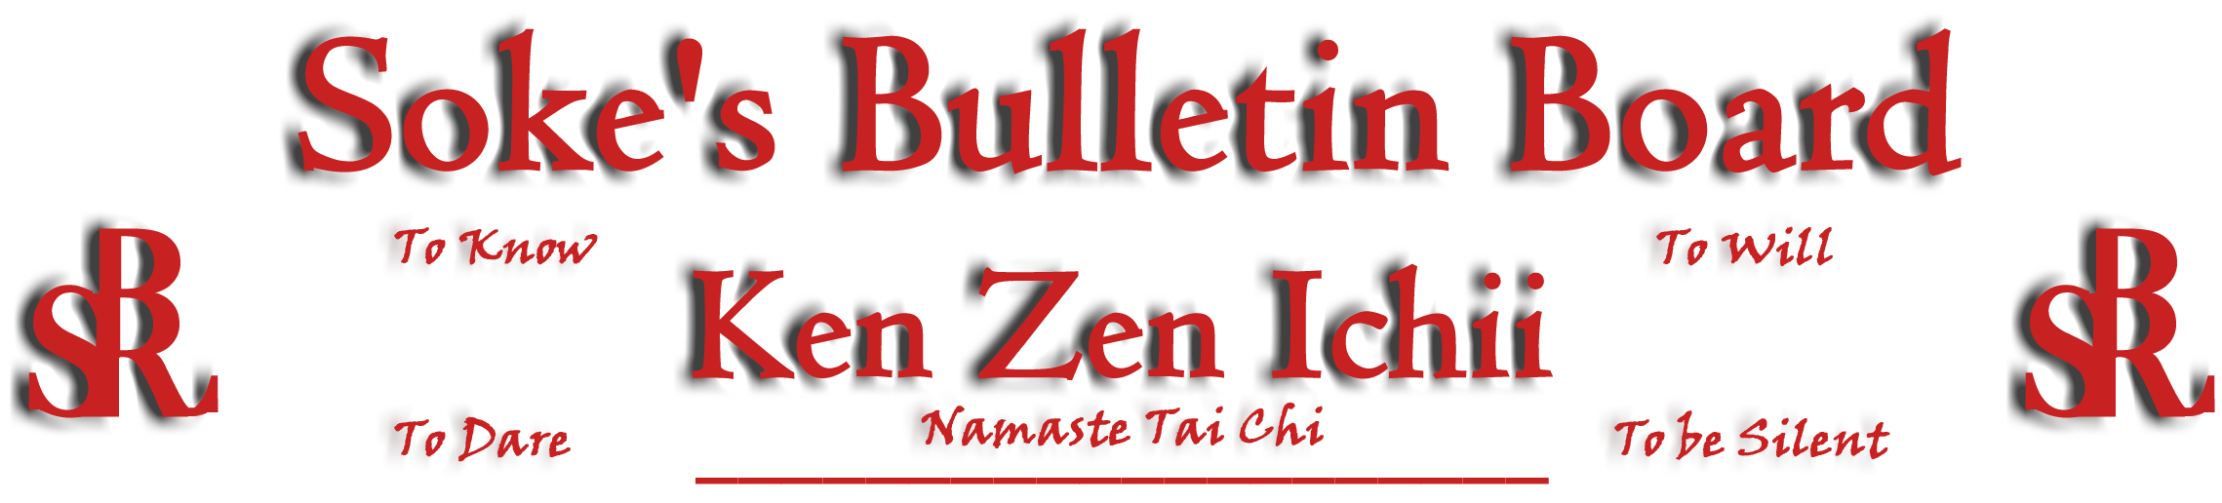
www.kenzenichii.com

January 2005

Renewal!!
The Opportunity for Renewal will be presented during the Black Belt Test scheduled for April 17, 2005 at 9:00 am. Come join us to witness, participate, and rejuvenate your KZI spirit. Together once again celebrate your moment in time. ALL OF US ARE ONE. Send an email to Soke for conformation ASAP!!!

Promotions
House of Soke: Troy Chappell has been promoted to Yellow Belt
Triston Pantone has been promoted to Yellow Belt

Healthy Kick: Jenee Pacheco has been promoted to Brown belt
India Pantin has been promoted to Brown Belt
Zachary Ficht has been promoted to Green Belt
Georgie Super has been promoted to Green Belt
Dwayne Boone has been promoted to Yellow Belt
Noah Halle has been promoted to Yellow Belt

House of Soke
Check the website for the new schedule and our new junior karate classes beginning this month.

Healthy Kick
We had a great and successful holiday party on Saturday, December 18. Thank you to all who attended.

Poughkeepsie YMCA
Happy Holidays!!! Please feel free to contact Sensei Caraway at (845) 453-4100.

KZI - California
Congratulations to all the Junior Samurai who earned their first Kyu!

The class for the Young Dragons is scheduled to begin on January 7.

BSR Silent Tigers
All is going well.

SokeVision
The Assumption of Man that he achieves the Ultimate impedes the process of possibilities…Soke

Muses, etc.
Generally speaking, when people contemplate the heart of a warrior, they consider it simply a Way in which a warrior learns to be resolute towards death. But this is not actually the essence of the Way: what distinguishes the warrior and is most basic in the Way of the Martial Arts is learning to overcome your opponent in each and every event…Your real intent should not be to die with weapons worn uselessly at your side. Miyamoto Musashi, “The Book of Five Rings”

Editor’s Notes
Please forward any articles or information you want to have added to the newsletter to Sensei Scott Dellinger. The newsletter is also distributed via email. If you have an email account and wish to receive the newsletter electronically, please contact Scott Dellinger at: Noah_Valle@hotmail.com, (818) 956-7931 or (626) 818-2041.

